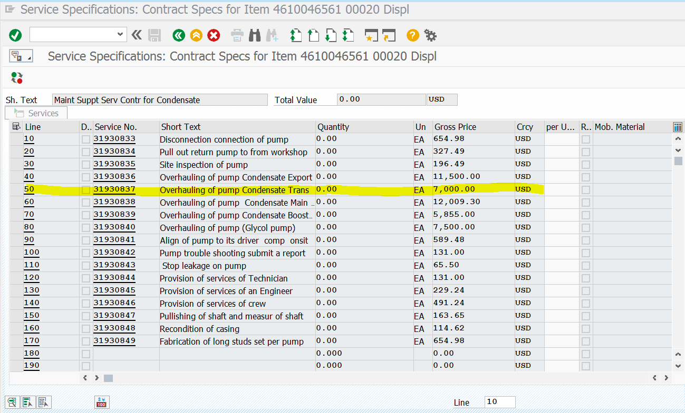

Estimate will be Minor overhaul $3000